STATION #3 - GRADED ACTIVITY PLAN
Graded activity in a paced, and planned way!
This means doing activity based on a PLAN, and NOT based on how you feel.
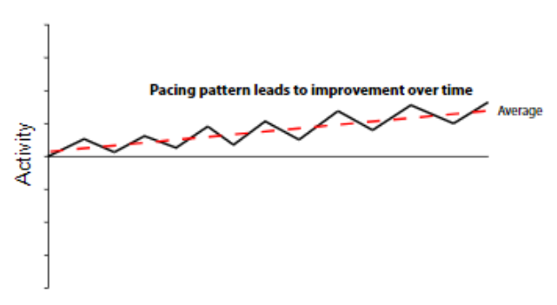
Step #1. Choose an activity
Step #2. Find your baseline
Step #3. Plan your progression
(increase by 10-20% each week)
Step #4. Try not to flare, but don’t panic if you do!
My long-term goal is….

My progressive plan is…

Date​ | Weekly goal​ | Outcome​
​ | ​ | ​
​ | ​ | ​
​ | ​ | ​
​ | ​ | ​
​ | ​ | ​
​ | ​ | ​
​ | ​ | ​

EXAMPLES
